RESEARCH AND EDUCATION ACTIVITIES:

**ACTIVITIES**

**Goals**

The core goals of this project – the Grinnell Resurvey Project (GRP) - are, through resurveys of early 20th C MVZ collecting sites, to:

1. Document changes in the distribution of small mammals and birds across the steep elevational gradients of the Sierra Nevada in California

2. Understand causes of changes in elevational limits, and improve thereby prediction of future impacts, and

3. Provide another specimen- and data-rich baseline of faunal distributions against which predictions of impacts of further environmental change can be assessed.

**Resurveys of small mammals and avifauna**

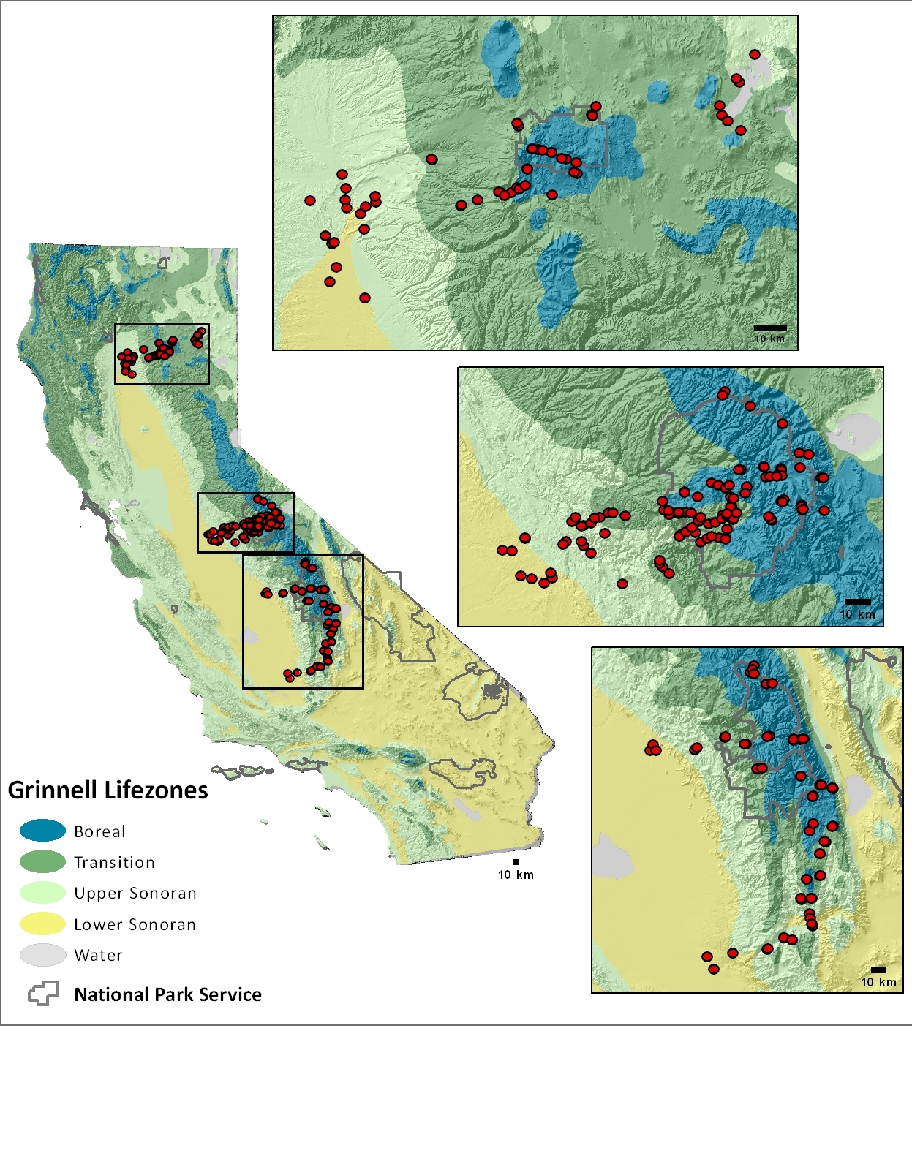We completed surveys of birds and small mammals along three elevation transects across the Sierra Nevada Mountains of California, from North to South: Lassen, Yosemite, and Southern Sierra regions. These surveys spanned over 5O latitude (35.42O to 40.73O) and 4O longitude (-118.12O to -122.30O), providing comprehensive voucher-backed surveys of birds and small mammals for four National Parks (Lassen Volcanic NP, Yosemite NP, Kings Canyon NP, Sequoia NP), eight National Forests (Lassen NF, Plumas NF, Tahoe NF, El Dorado NF, Stanislaus NF, Sierra NF, Inyo NF, and Sequoia NF) and numerous other state, federal and private land holdings. Small mammal surveys included 162 localities for 79,122 trap-nights and confirmed detection of 60 mammal species. A total of 251 bird surveys were conducted at 84 localities with 46,855 observations of 223 bird species recorded.

In relation to goal (3), we made extensive collections of small mammals, with a total of 7766 specimens (including tissues and associated data) now accessioned in the MVZ with the following accession numbers:

Northern (Lassen) – 19 accessions (14183, 14330, 14331, 14339, 14345, 14824, 14152, 14177, 14190, 14202, 14329, 14335, 14336, 14341, 14346, 14382, 14383, 14384, 14388); 1982 tissues from 1989 specimens

Central (Yosemite) – 6 accessions (13908, 13957, 14258, 13817, 13948, 14091); 4432 tissues from 4666 specimens

Southern (Sequoia) – 14 accessions (14457, 14587, 14765, 14462, 14471, 14481, 14583, 14591, 14598, 14599, 14606, 14607, 14619, 14757); 1108 tissues from 1111 specimens.

These resurveys were designed on the basis of analyses and data-mining of specimen records and locality data/attributes from MVZ field notes. These data on location, habitat type, trapping method/effort and daily capture records were extracted from historical field notes and assembled into a custom Access database, which also includes corresponding resurvey data.

**Analyses of observed changes in elevation**

Despite the increasing number of studies using resurveys of historical collecting sites to document changes in species distributions, the analyses of such data remain rather ad hoc and often fail to control for inevitable differences in survey design, methods etc (Tingley & Beissinger 2009). We put considerable effort into developing and applying occupancy modeling to control for differences in survey methods/effort from historical to present and to estimate detectability, and thus probability of false absence. This included extensive simulations to evaluate type I and II error rates when assessing change in range limits from resurvey data (Tingley et al. in press).

**Understanding observed changes in elevation**

To evaluation the role of 20th C climate change in driving species’ range fluctuations, we assembled available climate and vegetation layers from historic to present. These made use of an expert-interpolated climate database covering the relevant time periods (PRISM) and vegetation maps from the 1930s and present. For the first, we transformed the climate layers into Bioclim variables as typically used in distribution modeling. For the latter, our collaborator (J. Thorne, UC Davis) had previously digitized the early 20th C Weislander maps and developed a cross-walk (using California VTM classifications) to enable comparison with current vegetation. Using these, along with the observed range fluctuations, we then compared performance of alternative SDMs for predicting observed responses from the past to the present (Adam Smith) and testing whether observed vegetation change predicts responses of small mammals, via WHR classifications [Santos]. Our principle analyses evaluated whether temperature and/or precipitation change are major drivers of observed changes in elevation ranges (Tingley et al. in press; Rowe et al. in prep.]. In a further study of focal chipmunk species, we also tested whether climate +/or species interactions are the major determinants of range changes (Rubidge et al. 2009)

**Analyses of phenotypic and genetic change**

Given the presence of large series of specimens in the MVZ from early 20th C surveys and again 100 years later, we wanted to compare changes in phenotype and genetic diversity over time to contribute to understanding of proximate causes and effects of climate-driven changes in species’ distributions. Phenotypes and genotypes compared for species of lizard (*Sceloporus occidentalis*) and small mammals (*Peromyscus* mice and *Tamias* chipmunks) across the Yosemite transect. Analyses of changes in skull dimensions were extended across all three major transects for contracting vs stable species of chipmunks (A.-P. Assis, in progress) and ground squirrels (Eastman et al. 2012). To assess genetic change accompanying range fluctuation, we are focusing on declining vs stable species of chipmunks, first using microsatellite analyses of historical skins vs modern specimens. To improve assessment of demographic change and, potentially to detect selection responses, we have also developed and tested cost-effective methods, employing next-generation sequencing, for exome-scale sequencing of museum skins [Rowe et al. 2011; Bi et al. in press, in prep.).

**Data integration and sharing**

Project has driven considerable background work on the MVZ DB and web sites to improve ability to integrate diverse data types and to package information on species records over time and of ancilliary data for various stakeholders, especially western National Parks. For the future, we see great potential to develop strong on-line education products using these digital assets.